**DATA TIME ANALYSIS**

1. Method_1

A sample of client’s code:

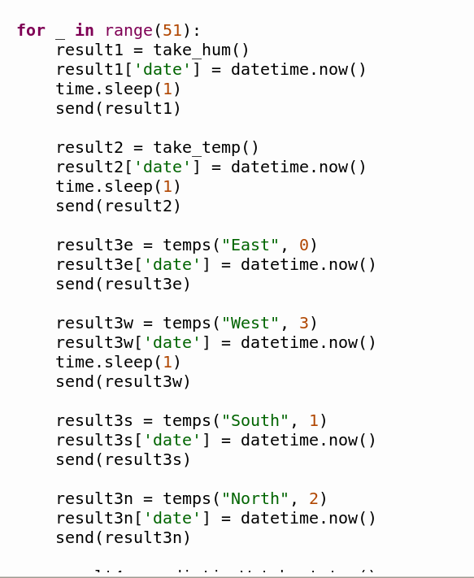

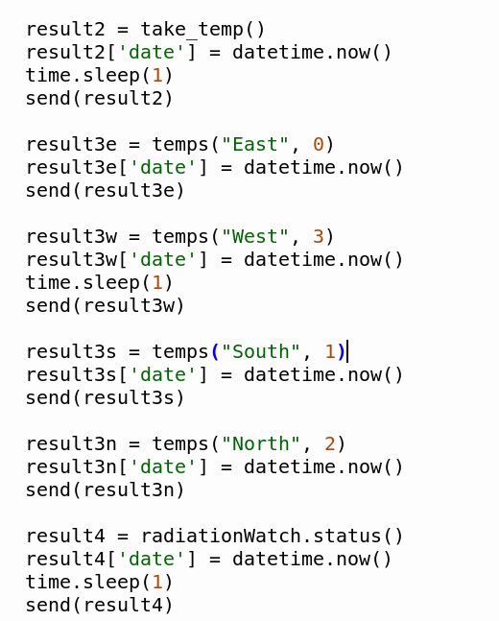

A sample of server’s terminal receiving data:

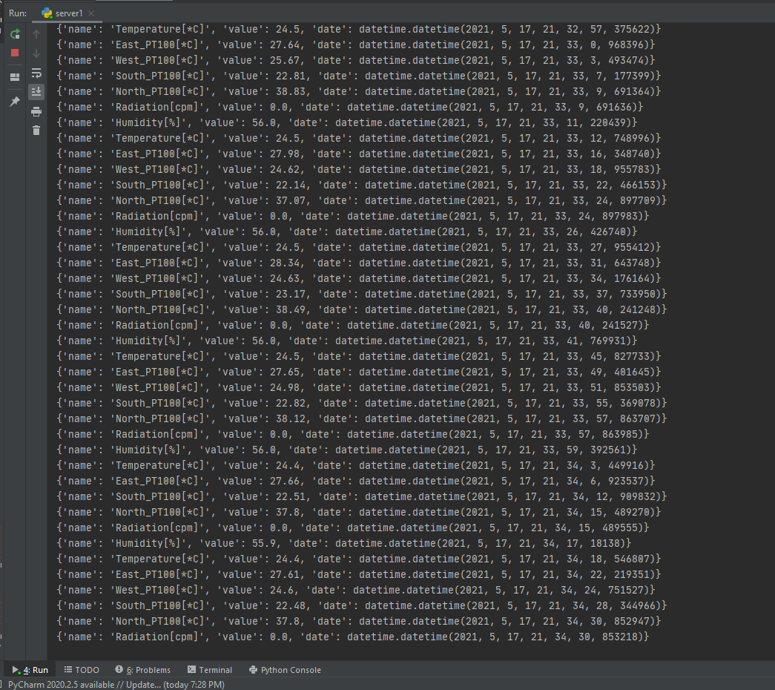

The time of sending 50 data packages with method 1:

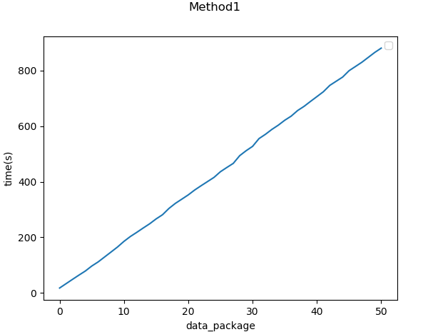

1. Method_2: Threading

Sending our data package separately, using a for loop with range(51) and creating 4 different threads for each measurement.

A sample of client’s code using threading:

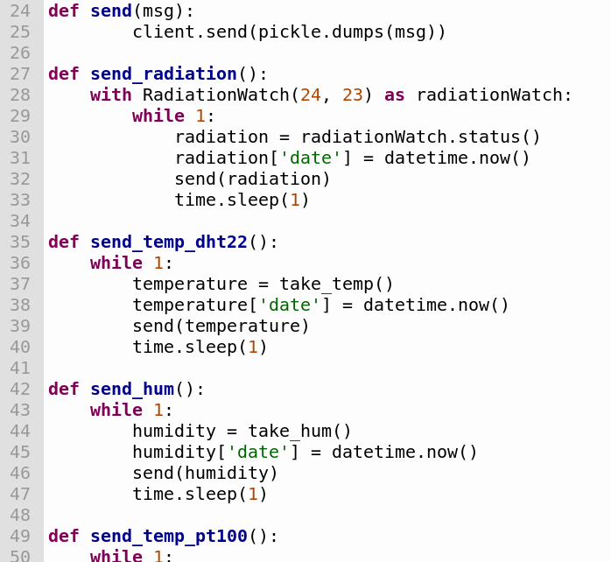

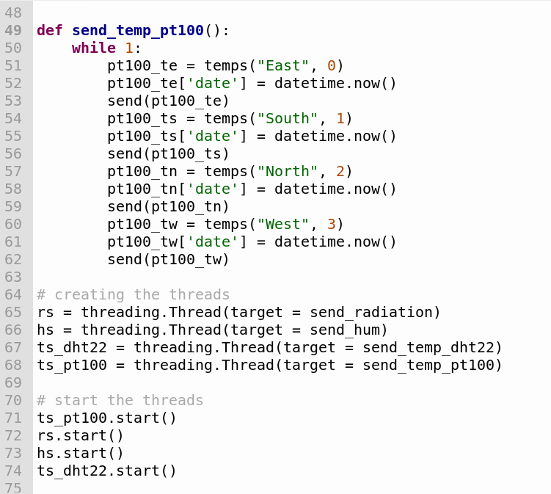

A sample of server’s terminal receiving data:

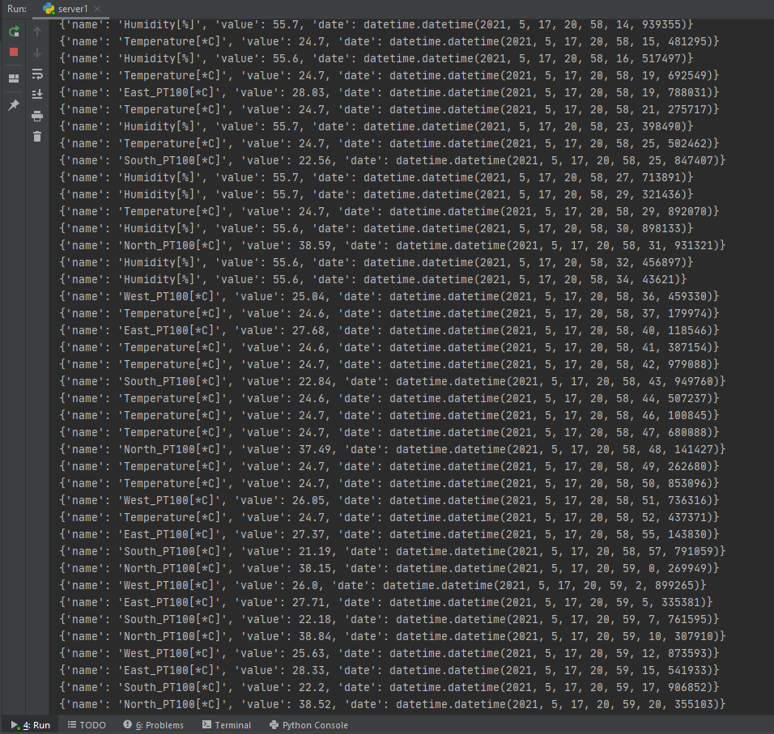

Notes:

As we can realize from the sent data it is deduced that the above functions have a different time complexity thus to avoid the delay in sending the data, we decided to use threading

With the aid of matplotlib we manage to measure each functions’ needed time to send 50 data packages as the below figures depict:

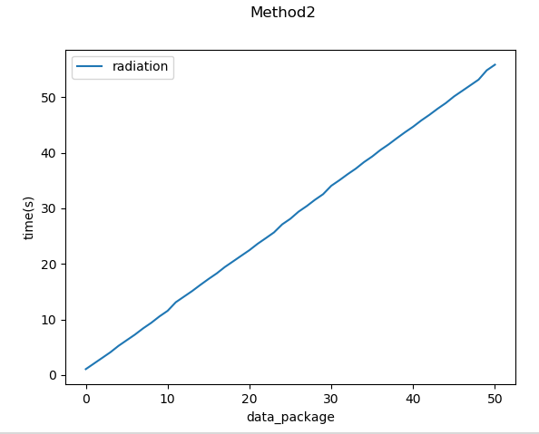

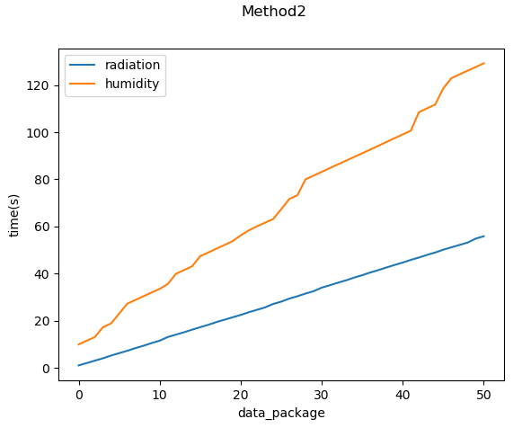

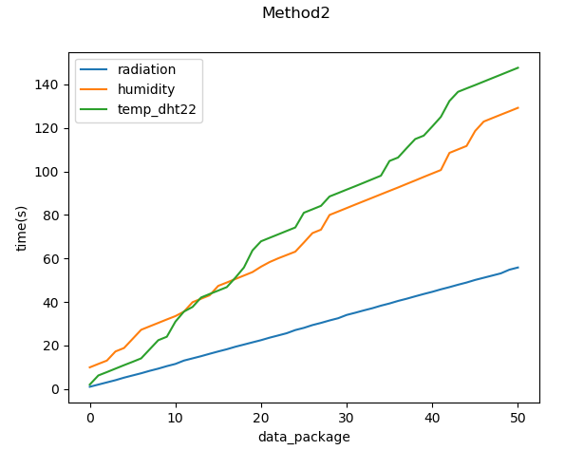

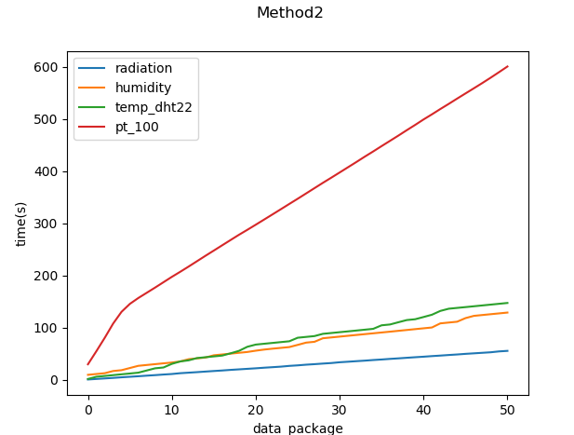

Zoom in at the end and the begging of the algorithm in order to view a more precise representation of time plot:

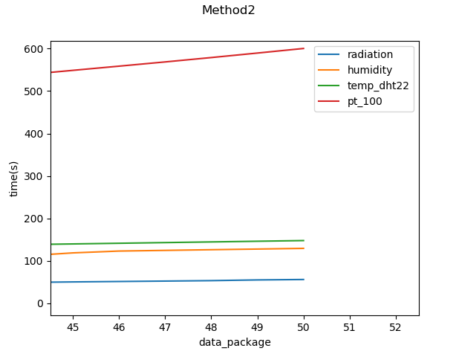

Pt100’s data rate =

temperature’s data rate (dht22) =

humidity’s data rate =

radiation’s data rate =

Total time = max(radiation_time, hum_time, temp_time, pt100_time) = 600 sec

Comparison of the above two methods:

Using the two methods to send the data to the sever

1. Radiation sensor’s plots:

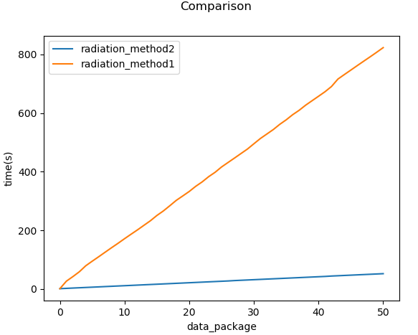

Time method 2 < time method 1

1. Humidity sensor’s plots:

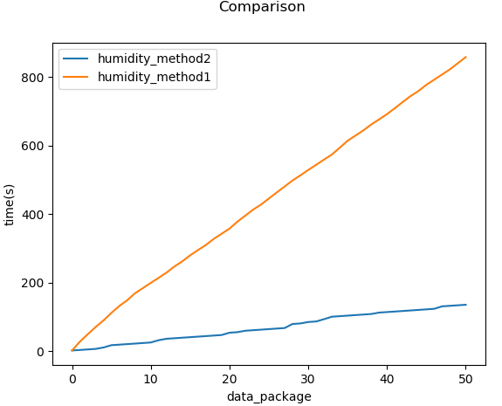

Time method 2 < time method 1

1. Pt100 thermistor’s plots:

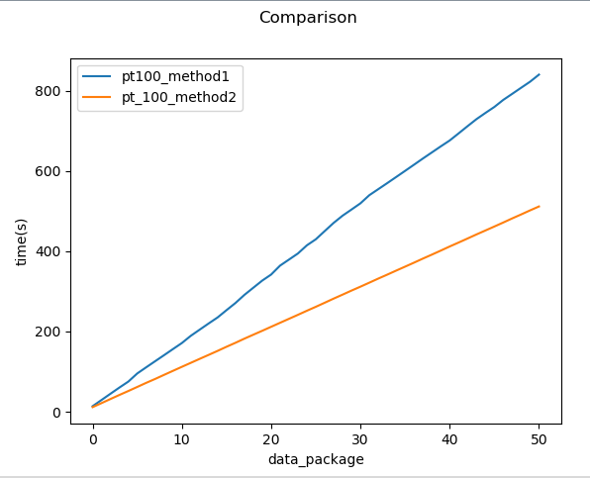

Time method 2 < time method 1

1. Temperature sensor’s(dht22) plots:

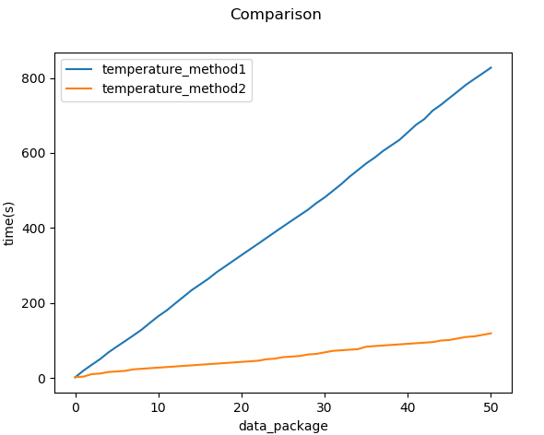

Time method 2 < time method 1

The pt100 function needs more time to gather and send the data to the server than the others due to its time complexity. It actually has worst asymptotic performance than the other functions/algorithms.

Consequently, taking into consideration all the above points, it is more efficient to use the second method as in the first one the data are sending all together and they are dependent, thus if a function needs more time to send the data all the others have to wait too. By using threading method, we are able to send the data independently without getting affected by any other function.

Notes:

We add a one second delay on sending the data (except from pt100 due to the already existed delay) in order to prevent our database from collapsing (or overload) idk chris better explanation